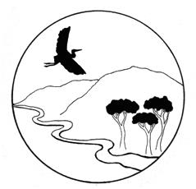

Russian River Property Owners Association

Officers: Brad Petersen, President; Paul Foppiano, Past President; Harry Black, Vice President;
Rickie Pina, Treasurer; Carolyn Wasem, Secretary

ANNUAL MEMBERSHIP MEETING
AGENDA
Date: February 20, 2024
Time: 4:00 PM
Location: Oriental Hall, Geyserville

- CALL TO ORDER – Brad Petersen, President
- PUBLIC COMMENT (regarding items not on the agenda)
- FINANCIAL REPORT PRESENTATION – Rickie Pina, Treasurer
- NOMINATION OF OFFICERS
- PRESENTATIONS: Alexander Valley Water Resilience
- Supervisor Glenn McGorty, Mendocino County representative on the Eel Russian Project Authority (ERPA) Board of Directors.

- David Manning, Sonoma Water. Options for New Potter Valley Diversion at Cape Horn Dam.
- Beth Salomone, Mendocino Flood & Water Conservation District.
- Panel Discussion and Questions
- UPDATE: Alexander Valley District Formation – Brad Petersen

Action: Membership Vote to Proceed with Water District Formation
Action: Form Committees for Outreach and Sponsorships

- NEXT BOARD MEETING – March 13th
- ADJOURNMENT
Our Mission
The Russian River Property Owners, a 501(c)4, encourages responsible stewardship of the Russian River Watershed in order to protect and enhance its integrity; while respecting private property rights.

